Cashmir Slaughter

Module 1 Configure a Development Environment

cash1.centralus.cloudapp.azure.com

https://github.com/Cashmir/CIS3917_Distributed_Databases

1.

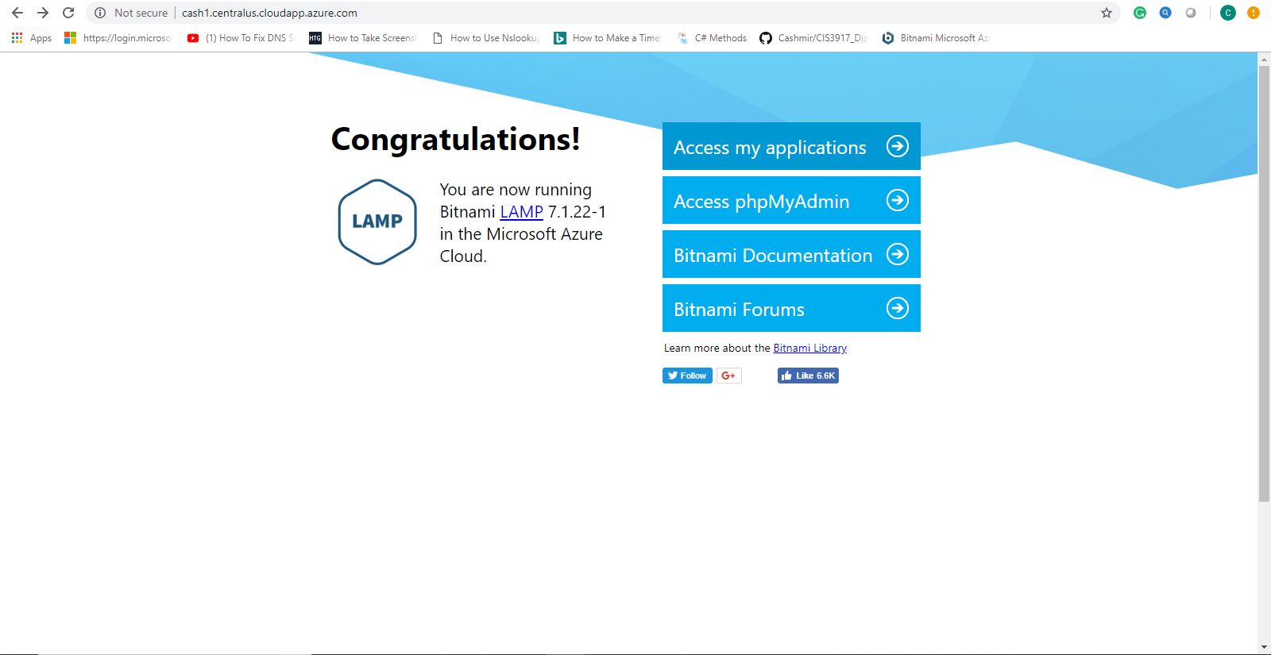

2.

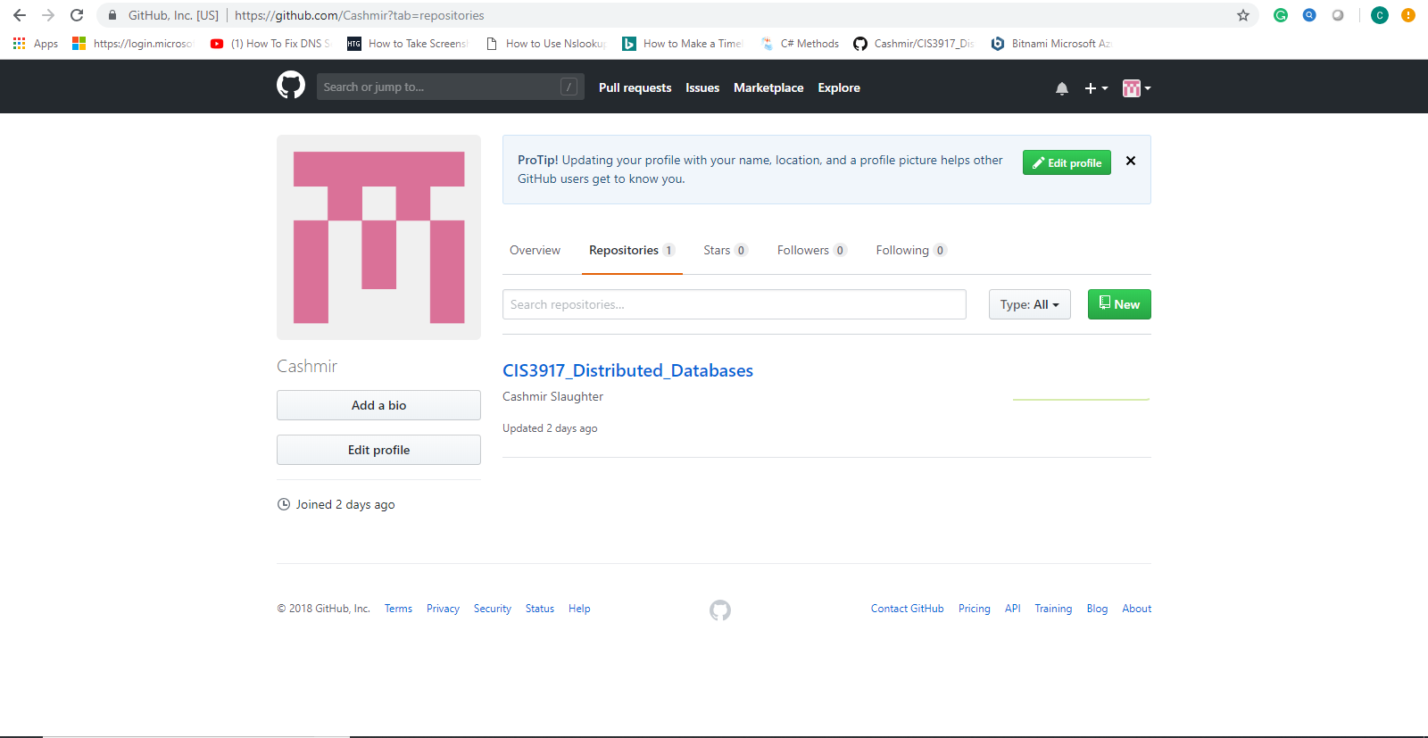

3.

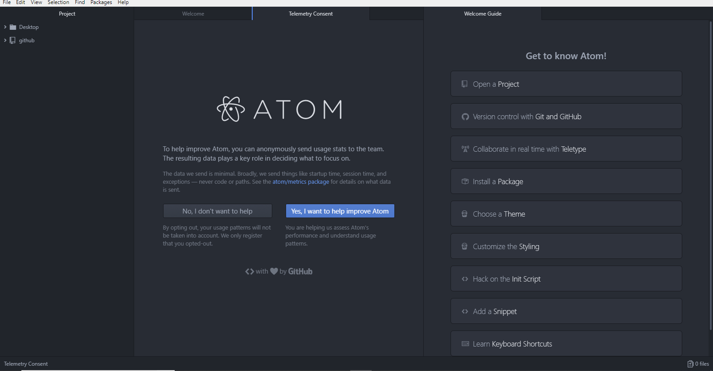

4.

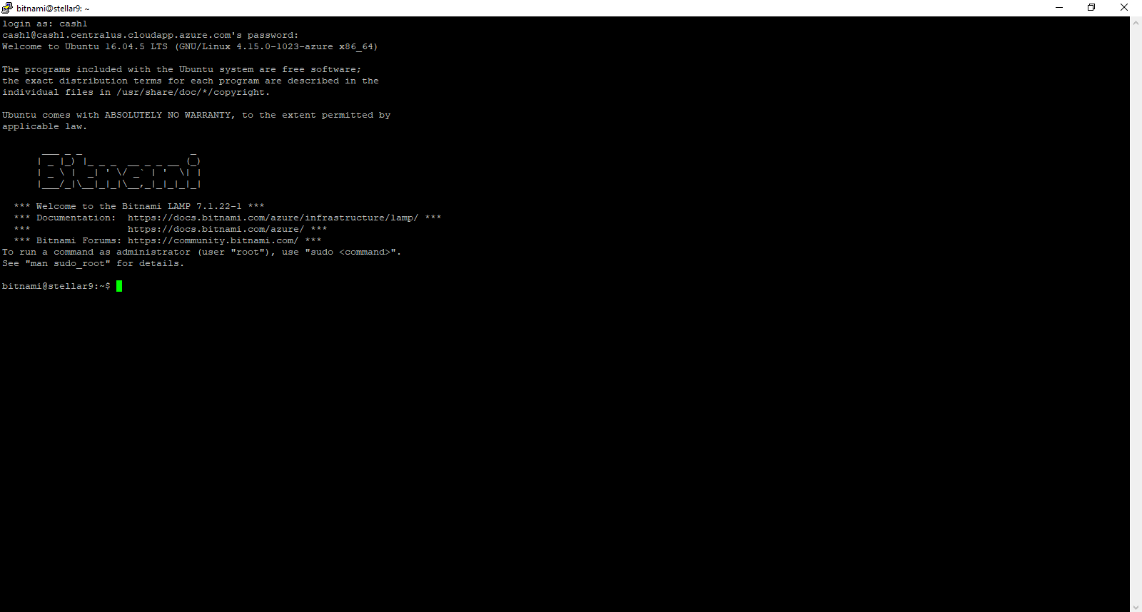

5.

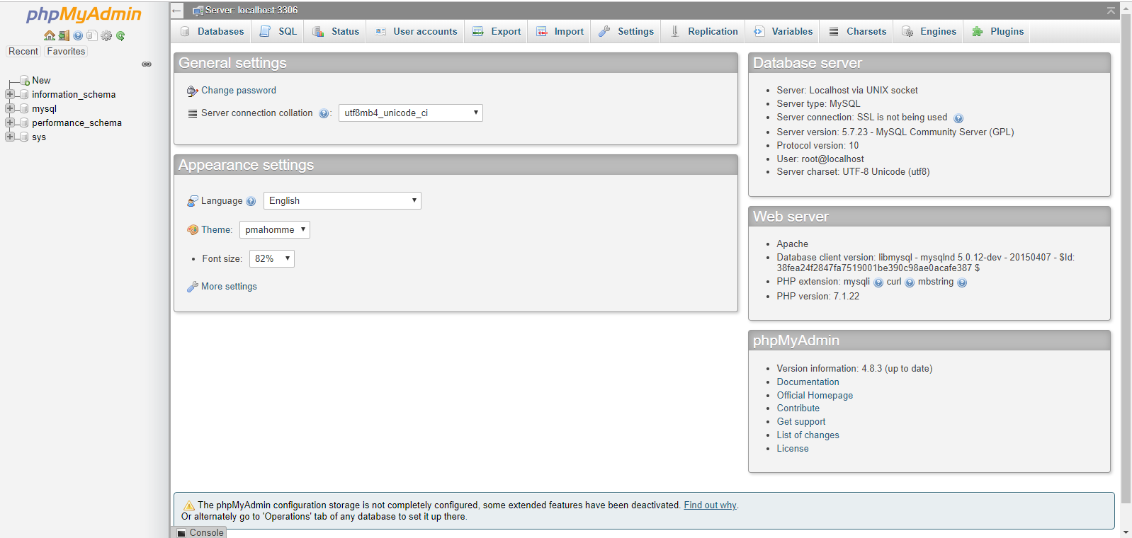

6.

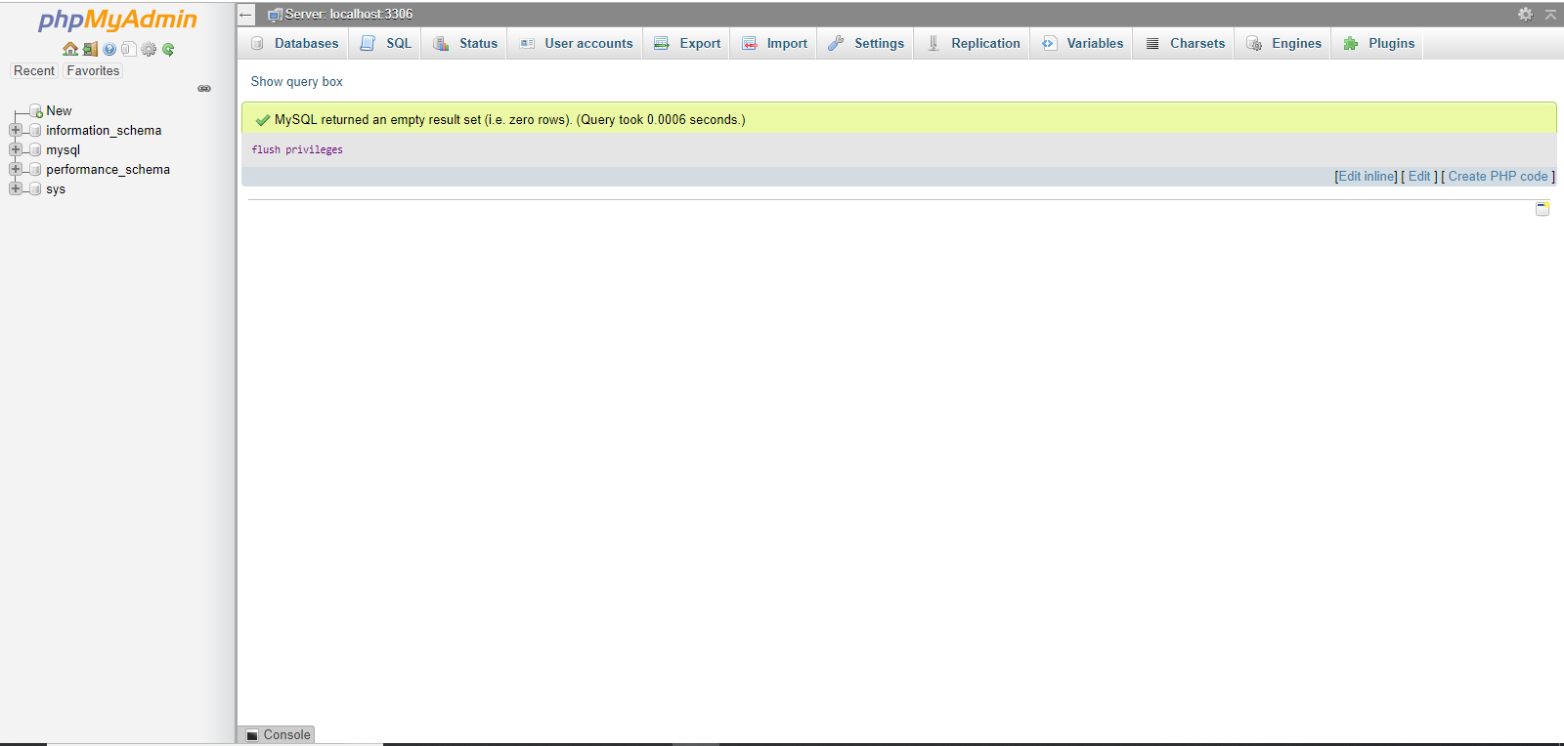

7.